Mentoring
Program
The Montgomery County
Veterans Treatment Court
Mentor Handbook

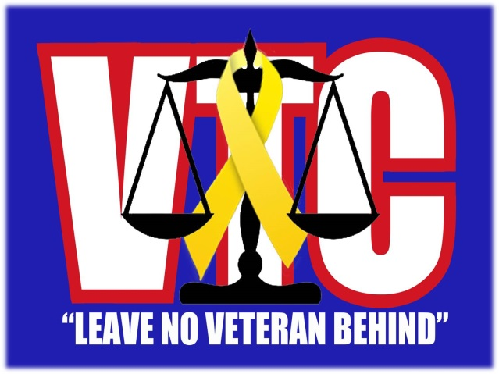

Montgomery County
Veterans Treatment Court Team:

Judge:  District Attorney:  Public Defender:  Probation Officer:  Law Enforcement:  VTC Director:  Evaluator:  Veterans Mentor Liaison:  Veterans Justice Outreach Specialist:  Case Manager:  Case Manager:  Team Chaplain:  Veterans Mentor Coordinator:  Court Liaison: | Kenneth R. Goble, Jr.  Michael Pugh  Meredith Gibson  Johnny Clark  Ronald Parrish  Edward Moss  Gene Lewis  Richard Meeks  Stacey Parsons  Nicole Porter  David Smith  Jerry Walker  Mary Ross  Katie Kastle
Mary Ross  VTC Mentor Coordinator  931-624-0772  Mddross2@msn.com | Edward Moss  Director  931-245-3180  elmoss@mcgtn.net

Why Veterans Treatment Courts?
Many veterans return from military service and find themselves facing unique personal challenges, including mental health problems or substance abuse, which they would not have faced if not for their military service. Criminal behavior, mental health problems and substance abuse often stem directly from service in combat zones and may be amplified by re-entry into home life. A key finding of a RAND 2008 study identified that nearly 20% of soldiers involved in the wars in Iraq and Afghanistan have a current mental health condition. Nearly 20% of service members reported having experienced a probable Traumatic Brain Injury. Some veterans may face additional obstacles due to military service such as sexual trauma, challenges that come from leaving children at home during deployment, and gay and lesbian stigma and prejudice.

Veterans Treatment Courts
Realizing that veterans have special needs that were not being adequately served, Buffalo City Court created the first Veterans Treatment Court in 2008. Beginning with, and then adapting, the structures of drug treatment courts and mental health courts, the Buffalo Veterans Treatment Court identified some of the specific issues facing veterans:

- The needs of many veterans are related to their military service

- Many veterans use drugs as a way of numbing or decreasing their stress levels

- Some illegal drug use may stem from the medicinal effect those drugs had on PTSD symptoms and other conditions while in the field

Veterans Treatment Courts (known as Veterans Court or Veterans Track in some jurisdictions) address these challenges in a forum that is conducive to veterans' rehabilitation. Where available, Veterans Treatment Courts work with civilian healthcare providers, local veteran agencies and the United States Department of Veteran Affairs. They utilize veteran mentors and mental health specialists to complement probation services and incorporate a therapeutic approach to afford veterans opportunities to transition into civilian life and regain stability.

Key Components of Veterans Treatment Courts
Veterans Treatment Courts operate similarly to drug treatment and mental health courts. Drug treatment courts operate within the guidelines of the Ten Key Components of Drug Court, developed by a commission of drug court practitioners in 1995. Veterans Treatment Courts feature the following 10 key operational standards which are adapted from the Ten Key Components.

Veterans Treatment Courts:

- Integrate alcohol, drug treatment and mental health services with justice system case processing

- Use a non-adversarial approach where prosecution and defense counsel promote public safety while protecting veteran participants’ due process rights

- Identify eligible participants early and promptly place them in the Veterans Treatment Court program

- Provide access to a continuum of alcohol, drug, mental health and other related treatment and rehabilitation services

- Monitor abstinence through frequent alcohol and other drug testing

- Respond to veteran participants’ compliance through a coordinated strategy

- Maintain essential, ongoing judicial interaction with each veteran

- Measure achievement of program goals and gauge program effectiveness through monitoring and ongoing evaluation

- Continue interdisciplinary education and promote effective Veterans Treatment Court planning, implementation and operations

- Forge partnerships among Veterans Treatment Court, Veterans Administration, public agencies and community-based organizations, generate local support and enhance Veterans Treatment Courts effectiveness

Mentor Component
An essential component of the Veterans Treatment Court program is the mentor program where veteran mentors act as peer support to veteran participants. Veterans are better served by having a support system that includes veterans who understand combat experience and the different aspects of military service. Mentors participate in a supportive relationship with participants to increase the likelihood that they will remain in treatment, attain and manage sobriety, maintain law-abiding behavior and successfully readjust to civilian life. The mentor program consists of mentor coordinators and veteran mentors. Their roles, responsibilities, requirements and qualifications are discussed in the following sections.

The Role and Responsibility of a Veteran Mentor
Veteran mentors are veteran volunteers responsible for serving as a supporter, guide and confidant for veteran participants. Mentors should provide support as participants’ progress through the Veterans Treatment Court and should feel comfortable working collaboratively to assist participants in successfully completing the directives of the court.

Veteran mentors should:

- When meeting with participants to assist in resolving their issues:
  - each meeting should build on the participants’ previous conversation
  - meetings should be conducted in person (when possible)
  - refer participants to appropriate services
  - facilitate an understanding of courtroom procedures
  - maintain appropriate boundaries with participants
  - be respectful and always speak with a positive tone

- When meeting with participants, mentors must NOT:
- make clinical recommendations
- give legal advice
- provide psychotherapy
- utilize a stern approach
- inappropriately extend the boundaries of their relationship
- offer or give monetary gifts
- post bond for mentee

- Work collaboratively with the other mentors and the mentor coordinator.

- Motivate participants utilizing a strengths-based approach by:
  - providing encouragement to participants by highlighting their strengths including, talents, skills and knowledge
  - focusing on what has been successful
  - believing that participants have the potential to learn, grow and change

- Maintain federal confidentiality standards.

- Attend clinical and legal training programs supported or provided by the Veterans Treatment Court.
- Mentors should attend an initial training session where topics may include: Veterans Treatment Court’s policies and procedures, mentoring dos and don’ts, substance abuse, mental illness, Post-Traumatic Stress Disorder and Traumatic Brain Injury.

- Communicate with their mentor coordinator to resolve any issues regarding time commitments, resistant participants or unmanageable challenges.
- If a mentor fears for the safety of a participant’s life call 911 and then report to the mentor coordinator immediately.

- Update the mentor logbook notes after speaking with a participant.

- Commit to a period of time, usually 12 months, to mentor in the Veterans Treatment Court.

- Provide a valid military service record (DD214 or DD215) and submit to background check.

Requirements and Qualifications for Veteran Mentors

Mentors should:
- complete a mentor application form (sample is attached)
- provide a valid DD214 or DD215 (honorable discharge is preferred)
- submit to a background check
- be respectful of individual differences and maintain appropriate boundaries with participants
- not be an active employee of law enforcement or a member of any other organization that may present a conflict of interest with the mentor program
- commit to a time period of 12 months

The Role and Responsibility of a Mentor Coordinator
Mentor coordinators ensure the efficient and successful operation of the mentor program in a Veterans Treatment Court. Mentor coordinators are volunteers that are responsible for assigning veteran mentors to participants, supporting veteran mentors in all aspects of their work and managing mentor training programs and mentor assignments.
Mentor coordinators must be familiar with their local Veterans Treatment Court and veteran services.

Mentor coordinators should:
- Find appropriate mentors for the Veterans Treatment Court program.
  - This may require conducting presentations in the community regarding the Veterans Treatment Court.
  - Mentors cannot be active employees of the active law enforcement or a member of any other organization that may present a conflict with the mentor program.

- Match mentors with participants based on shared qualities and backgrounds to the greatest extent possible. Factors to consider may include:
  - branch of service
  - type of service (i.e., combat and location of service)
  - gender
  - general age group

- Schedule the appropriate number of mentors needed for each court session.
  - Mentors should be present whenever Veterans Treatment Court is in session to provide immediate support for participants appearing in court.

- Act as a resource for the mentors by:
  - accommodating conflicts in a veteran mentor's personal schedule
  - collecting and reviewing mentor logs completed by mentors and monitor the nature of a participant's progress in the Veterans Treatment Court
  - Placing mentors in touch with local Accredited Service Officers who can help appropriate veterans secure benefits from the U.S. Department of Veterans Affairs. These trained officers can be found in local government offices and in local service organizations such as The American Legion, The Military Order of the Purple Heart and Vietnam Veterans of America.

- Work with the Veterans Treatment Court staff to resolve issues and motivate participants through challenges.
  - In some instances, mentors may bring concerns regarding a participant to the attention of their mentor coordinator. The mentor coordinator is then responsible for contacting the Veterans Treatment Court in a timely manner to ensure that the participant receives appropriate support.
  - If the mentor coordinator determines that a mentor is not adequately fulfilling their responsibilities, the coordinator must contact the Veterans Treatment Court staff in a reasonable and timely manner and remove the mentor from the program.

- Maintain federal confidentiality standards.

- Attend clinical and legal training programs supported or provided by the Veterans Treatment Court.

- Maintain access to the mentor logbook or case management notes.

